## K-means clustering

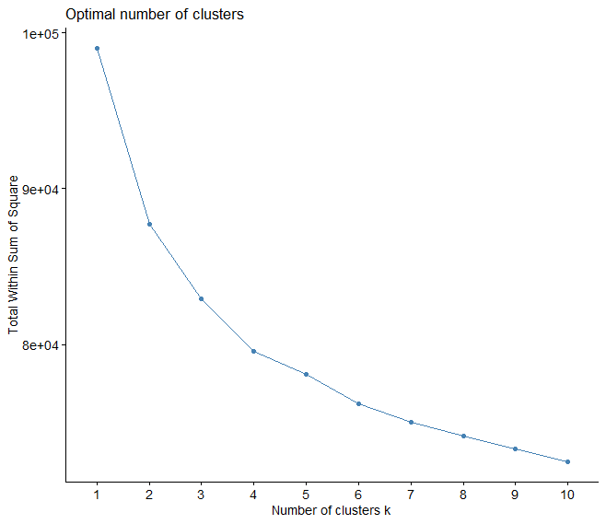

Based on the elbow method, the optimal number of clusters for our gene expression data is **k = 3**. This was used to proceed with clustering analysis, enabling us to categorize patients into three distinct groups based on their gene expression profiles.

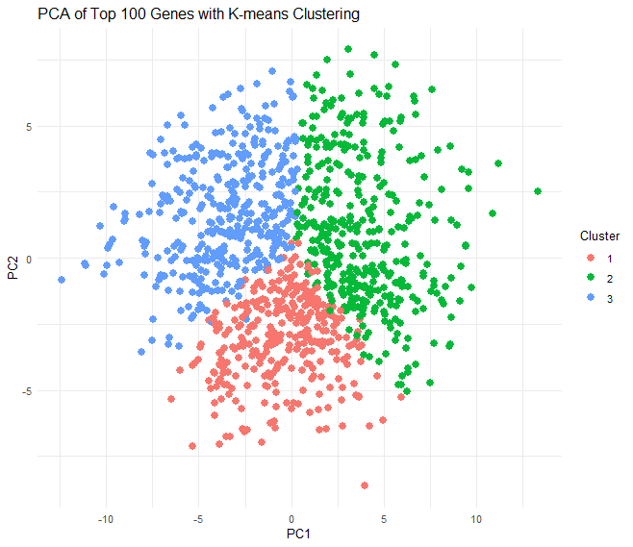

The plot shows how patients are distributed in the reduced dimensional space and helps to visualize the separation between clusters. This clustering forms the basis for further survival analysis within each cluster to explore the impact of gene expression on survival patterns.